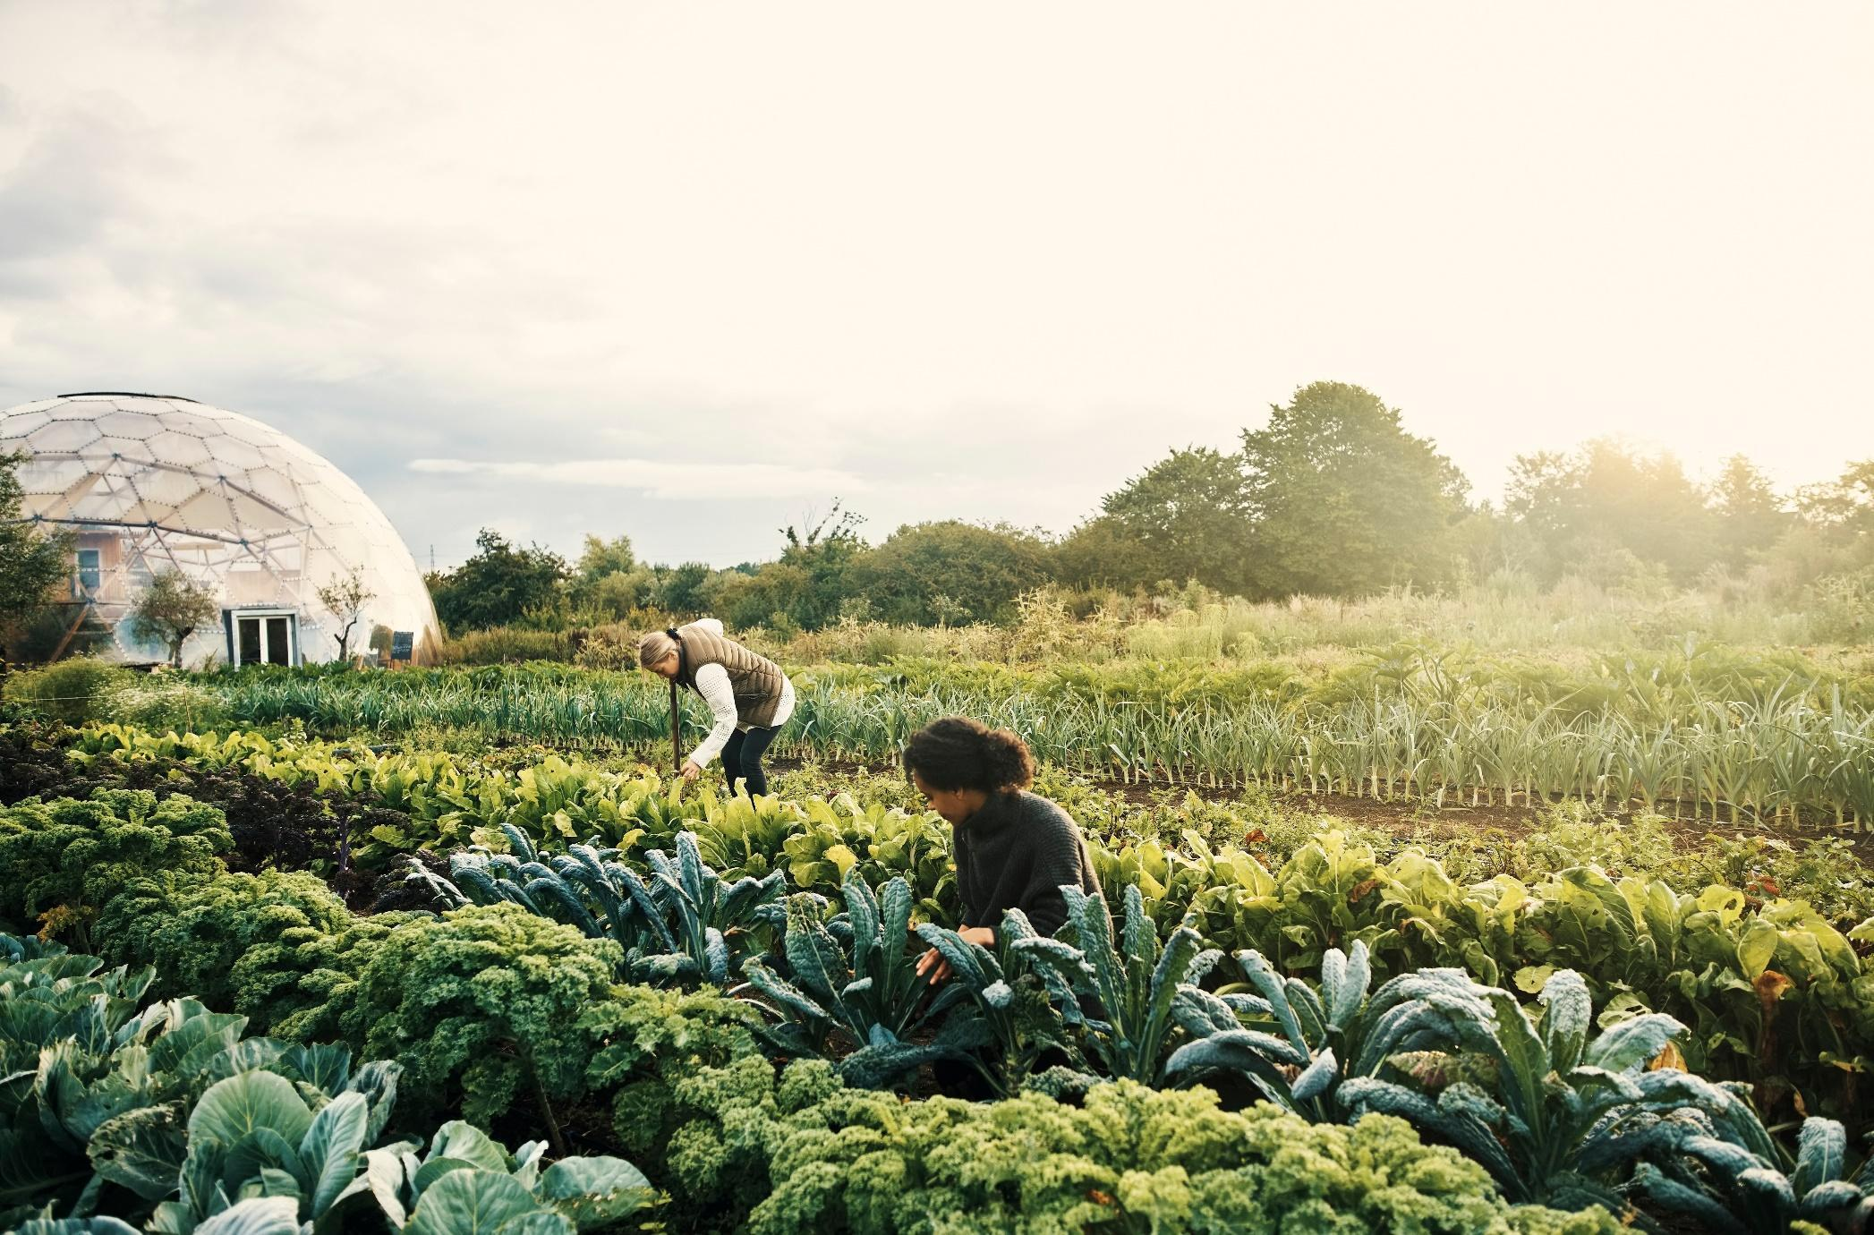
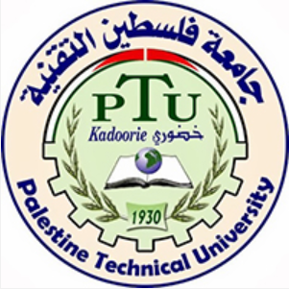

1-YEAR PROFESSIONAL DIPLOMA IN URBAN AGROECOLOGY & FOOD SOVEREIGNTY

OUR FOOD SYSTEM IS IN CRISIS
Industrial agriculture is one of the leading causes of climate change and health inequity around the world. In Palestine, caught between shrinking territory and urban expansion, farmers’ and fishers’ livelihoods are under threat, critically endangering Palestinian’s unique food system. To overcome these problems, actions are urgently needed to address economic, environmental, health, social, and cultural objectives simultaneously. This requires a systemic approach that brings in farmers' voices for co-learning and citizen engagement to stimulate new ways of thinking and acting collectively to tackle the ‘wicked problems’ that have contributed to the intersecting crises of climate change, biodiversity loss, poverty and ill health.
Agroecology offers the potential to regenerate the environment, cool the planet, and provide good, healthy food for all. It applies an integrated system of plant and animal production practices modelled on relationships found in nature. It is also a way of understanding and designing food systems using social, ecological, and political principles to regenerate nature and create a more just society. And it is rooted in indigenous and traditional practices intricately connected to ancestral knowledge(s), combined with scientific knowledge to address the current food crisis.
WHAT IS URBAN AGROECOLOGY?
Urban agroecology aims to identify and define newly articulated relations between communities engaging in land cultivation and soil stewardship that benefit nature on one hand, and urban consumers dependent on increasingly globalised and highly commodified food systems over which they have little control. Urban agroecology is about more than changing farming techniques in urban or peri-urban settings, it is also about transforming policy, planning, science and economies to bring about more just food systems.
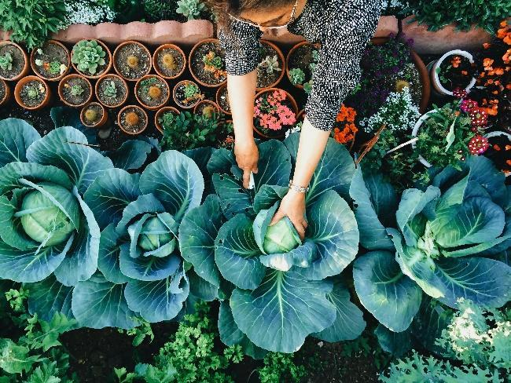
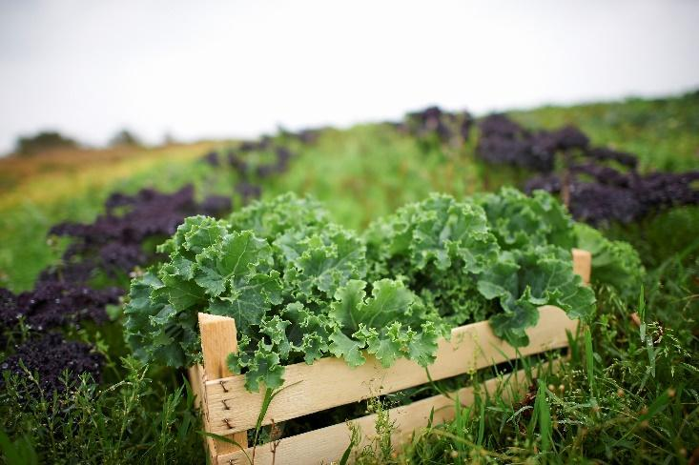
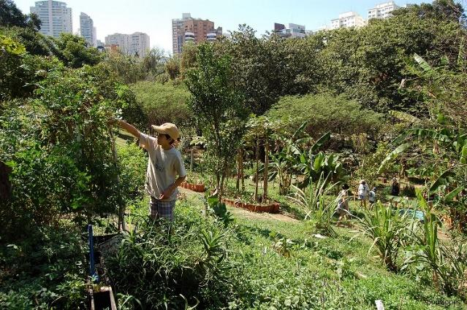

AIMS OF THE DIPLOMA
This one-year programme offers a unique approach that combines the political economy of food systems with socially and ecologically regenerative farming practice. It aims to prepare a new generation of interdisciplinary thinkers, policy makers, practitioners, and activists capable of reimagining and transforming a food system currently dependent upon the importation of agrochemicals and industrially produced food, that denudes and pollutes Palestinian’s agroecosystem and undermines its food sovereignty.
SPECIFIC OBJECTIVES OF THE PROGRAMME
This diploma presents the science, practice and movement of Urban Agroecology & Food Sovereignty and will qualify students as Urban Agroecologists. The programme’s specific objectives will result in students:
- Becoming familiar with ecological, social, and political economy perspectives while investigating contemporary problems in the global-local agrifood system.
- Becoming familiar with current research and applied concepts and applications within the field of urban agroecology and food sovereignty.
- Experiencing hands-on field exercises in baladi farming systems, students learn about ecological and social research, and build the methodological and analytical skills that are commonly used in agroecology and agri-food systems research.
- Gaining teamwork skills through working, experimenting, and learning together in groups.
- Developing critical thinking and communication skills throughout by participating in discussions and preparing written and visual materials.
OUR APPROACH
Using participatory, holistic, and equity-centred approaches to co-learning, research and citizen engagement, this diploma will support students from diverse backgrounds to co-create and mobilise knowledge(s) that stimulate ethics of care for soil and human health to enhance the quality of life for farmers and society. While being grounded in the ecological and political realities of food systems facing a range of threats, we challenge students to co-develop solutions that are more economically robust, socially just and ecologically sound. To do this, we foreground Participatory Action Research (PAR) and Participatory Learning & Action (PLA) approaches, working in close partnerships with impacted communities, farmers, and other local stakeholders.

HOW IT WORKS
The four modules each consist of up to 14 sessions lasting three hours. While equally practical and theoretical, the programme is grounded in histories of dependencies and agrarian politics, neo-/colonial policies, and the regional impacts of global accumulation. It will guide students to identify key questions and practise a range of methods for integrating different knowledge(s) and data from multiple sources and perspectives (ie. farmers, academics, activists, policymakers). A transdisciplinary approach is used to both critically assess and better understand issues associated with the agrifood system. By employing Participatory Action Research (PAR) and Participatory Learning & Action (PLA), the programme will facilitate encounters with agroecology practitioners and food sovereignty activists from across Palestine, the region and internationally to promote transnational solidarity.

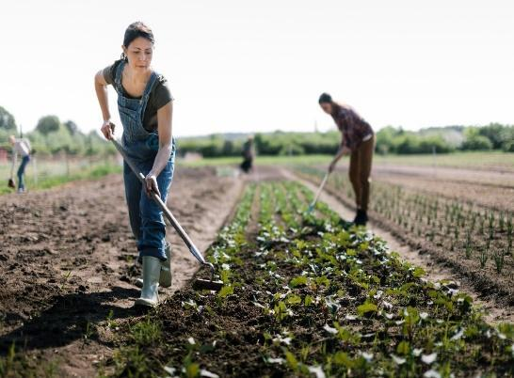

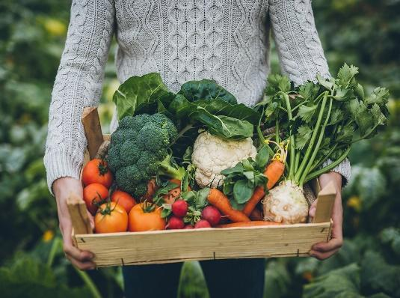
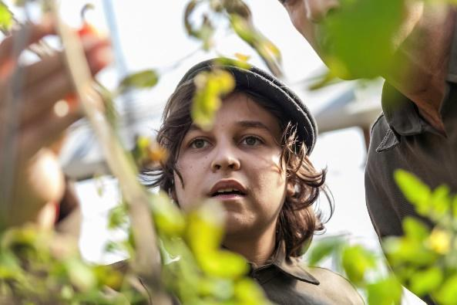
OUR MODULES:
4. Alternative Economies & Regenerative Enterprise: explores organizational strengthening, asking: How do we learn across intersections to build solidarities; how do we nurture our foodways to reconnect culture, food & environment through resourcefulness and resistance? Plus 12 hours in-service learning & research placement.

1 Urban Agriculture Practice:
includes sessions on urban soil & water management, nutrient cycling, integrated cropping & livestock systems, integrated pest management, and investigations on agrobiodiversity and agroecological rehabilitation, and critical approaches to technologies, in addition to field visits with farmers.
2. Urban Agroecology for Food Sovereignty: Introducing key concepts and dominant discourses of the industrial food paradigm, colonisation and marketisation, including challenges & transitions to food sovereignty, community self-organisation, gender & feminisms, and power & participation in urban planning & food policy.
3. Participation in Learning, Practice & Action: Introduction to participation and transdisciplinarity for understanding &
transforming knowledge. 50% of this module involves students learning and working in teams - setting up, managing, and documenting their own food growing experiments at PTUK campus (Tulkarem and Al Aroob)
FINAL PROJECT
For their final graduation project, students select an action research focus of their choice, potentially a case study from their Module 4 in-service research & learning placement within the Urban Women’s Agripreneur Forum (UWAF) or the City Food System Actor Networks (CFSANs) in Palestine, to build on their learning throughout the programme. This final project might take the form of a written thesis or creative multimedia output.
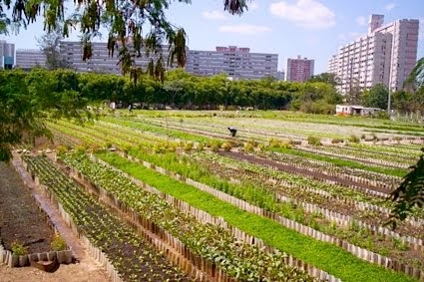

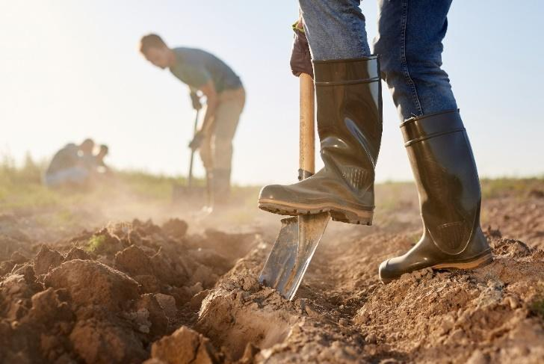

ORIGINS OF THE DIPLOMA
This diploma results from a collaboration between the Palestine Technical University – Kadoorie, University College of Applied Science (UCAS), the Palestinian Hydrology Group for Water and Environmental Resources Development (PHG), and the Centre for Agroecology, Water and Resilience (CAWR) at Coventry University, UK under an action research project titled Gaza Foodways - Towards Resilient Women-Led Urban Agroecological Food Systems, which is funded by Canada’s International Development Research Centre (IDRC).
OUR VALUES
Three key pillars are applied to this diploma:
- We are working toward an ecologically sound and socially just food system by prioritising long-term, systems-level work rather than quick fixes.
- We foreground Participatory Action Research (PAR) and Participatory Learning & Action (PLA) approaches, working in close partnerships with impacted communities, farmers, and other local stakeholders.
- We centre equity in all that we do, recognising that unless we are actively working against exploitative land and labour relations, gender and racial inequality and colonial patterns of extraction then we become complicit in reproducing these patterns of oppression.

STUDY WITH US

We welcome applicants with an interest in transforming food systems as farmers, NGO practitioners, policy makers & activists. We particularly encourage applications from women and are offering 10 funded spaces for women working in food & farming who are unable to cover their tuition, and 10 spaces for women working as agricultural extensionists. A further 10 self-funded spaces will also be available.

Application deadline: 20th February 2026 / Start date: March 2026

GUIDANCE ON THE APPLICATION PROCESS FOR BOTH FUNDED AND SELF-FUNDED PLACES CAN BE FOUND ON THE PTUK WEBSITE

