PROFESSIONAL DIPLOMA IN
URBAN AGROECOLOGY & FOOD SOVEREIGNTY
IN PALESTINE – 2026

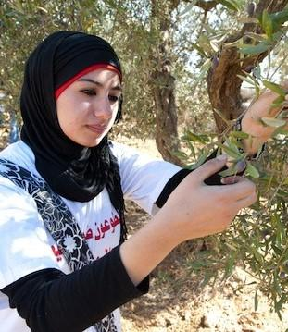

Joint Diploma between the University College of Applied Science (UCAS) in Gaza,
and the Palestine Technical University - Kadoorie, Tulkarm.

Table of Contents
1. Introduction 3
1.1 Food system in crisis
1.2 Agroecology & Urban Agroecology
1.3 Origins of the Diploma
2. Aims & Objectives of the Diploma 6
2.1 Course Aims
2.2 Specific Objectives
2.3 Pedagogical Approach
2.4 Course Value
2.5 Who the course is for
3. Course Structure, Credits & Assessments 8
3.1 Structure of Modules (x5)
3.2 Credits & Study Plan
3.3 Assessments
4. Module Syllabi (x5) 12
4.1 Foundation Mini-module
4.2 Agroecology in Practice
4.3. Urban Agroecology for Food Sovereignty
4.4 Participation in Learning, Practice and Action
4.5 Alternative Economies & Regenerative Enterprise
4.6 Final Project
1. INTRODUCTION

1.1 A Food Systems in Crisis
Industrial agriculture is one of the leading causes of climate change, environmental degradation, poverty and health inequity around the world. The systematic use of synthetic fertilizers, herbicides and insecticides has greatly depleted soils’ beneficial organisms and biodiversity. Furthermore, specialisation for intensive mono-cropping, with the progressive selection of varieties by industrial plant breeders, has reduced both plant resilience to climate events, and the nutritional value of those plants.
The monopolisation of industrial agriculture and agri-technology has resulted in technical lock-ins that have indebted farmers, while multiplying diet-related diseases for consumers. These features of industrial agriculture, alongside international agreements that penalise small producers and local markets, devalue local farmers and erode their knowledge. Generations of farmers across the world have been impoverished and disempowered of their capacity to maintain and exercise sovereignty over their food systems.
The international movement of food sovereignty and agroecology has emerged over the last four decades, initiated by farmers across the world, to build cross-border alliances to support the self-determination of farmers and producers who strive to produce food, fibers and medicine in harmony with nature, and in respect of people, their knowledge, their labour and their health. This movement, which has deep roots in indigenous and grassroots organising, has reached academia and education, where it has been shaking the foundations of western education systems and their complicity with colonial and capitalist ventures.
Across Palestine, caught between annexation and urban expansion, farmers’ and fishers’ livelihoods have been under threat for decades, critically endangering Palestine’s unique food system. Palestine is also a captive market, where colonial occupation and control has been shaping economic opportunities, rendering Palestinian farmers dependent upon the occupations inputs and products. To confront these realities, actions are urgently needed to address economic, environmental, health, social, and cultural objectives simultaneously. This requires a systemic approach that brings in farmers' voices for co-learning and citizen engagement to stimulate new ways of thinking and acting collectively to tackle the ‘wicked problems’ that have contributed to the intersecting crises of climate change, biodiversity loss, poverty and ill health.
This Professional Diploma programme offers a unique approach that combines the political economy of food systems with socially and ecologically regenerative farming practice. This is needed to prepare a new generation of interdisciplinary thinkers, policy makers, practitioners and activists capable of critically deconstructing dominant discourses while re-imagining and transforming a food system currently dependent upon emergency feeding and the importation of industrially produced food and synthetic inputs.
1.2 Agroecology and Urban Agroecology
The principles and values of agroecology have been embraced by both the food sovereignty movement and international institutions, such as FAO, UNDP, IFAD. Agroecology offers the potential to regenerate the environment, cool the planet, and provide good, healthy food for all, while respecting people’s dignity and wellbeing. It applies an integrated system of plant and animal production practices modelled on relationships found in nature. It is also a way of understanding and designing food systems using social, ecological, and political principles to conserve and regenerate nature and create a more just society. And it is rooted in indigenous and traditional practices intricately connected to ancestral knowledge(s), combined with scientific knowledge to address the current food crisis.
While most agroecology ideas and movements are rooted in rural lifestyles and imaginaries, with the progressive urbanisation of the world it has become necessary to think about how agroecology’s principles, practices and political work be adapted to effectively produce the desired change in urban contexts. “Urban agroecology”, therefore aims to identify and define newly articulated relations between communities engaging in land cultivation and soil stewardship that benefit nature on one hand, and urban consumer’s dependent on increasingly globalised and highly commodified food systems over which they have little control. Urban agroecology is about more than changing farming techniques in urban or peri-urban settings, it is also about transforming policy, planning, science and economies to bring about more just food systems (Deh-Tor 2017; Tornaghi and Dehaene 2020)

1.3 Origins of this Diploma
Working with an agroecology and feminist political ecology frameworks, this Diploma was developed as part of a broader project dedicated to support women farmers in Gaza, and offer opportunities to deepen understanding of agroecology, and its principles and practices.
The Diploma is a collaboration between the University College of Applied Science (UCAS), and the Centre for Agroecology, Water and Resilience (CAWR) at Coventry University, UK - and sits within an action research project titled Gaza Foodways - Towards Resilient Women-Led Urban Agroecological Food Systems (2021-26) with the Palestinian Hydrology Group for Water and Environmental Resources Development (PHG), and the Gaza Urban and Peri-Urban Agriculture Platform (GUPAP).
Together with the Urban Women’s Agripreneur Forum (UWAF) established by GUPAP in 2019, the project aimed to support a shift toward women-led agricultural research, practice and policy formulation, and advance women’s socioeconomic and political participation in food system planning, organising and resourcing in ways that support food sovereignty by strengthening urban-rural foodways connected to territorial markets.

Our emphasis was on supporting new, and strengthening existing, networks of micro and small-scale producers and processors to restore eroded knowledge, recover lost resources and rebuild bonds between people and the landscape upon which they depend. To this end, we facilitated processes that invited researchers, students, policy-makers and influencers, together with producers and processors to initiate collaborative relationships for new ways of thinking and acting together for change.

The Gaza Foodways project aimed to:
- Establish and foster 4-6 inclusive inter-sectoral City Food System Actor-networks to develop & implement collaborative action plans in Gaza City and Khan Yunis.
- Award and mentor 4 Challenge Prizes to transdisciplinary women-led research teams to co-develop technical or social innovations with the Urban Women’s Agripreneur Forum (UWAF)
- Support the integration of 3 new food forums into UWAF with skills for improved adaptive capacity for agroecological production and processing, social organising and leadership, and marketing to optimise economic participation.
- Co-create an innovative professional diploma in Urban Agroecology & Food Sovereignty established to enable students to critically engage with food system transformations as producers, extensionists, NGO practitioners and/or civil society activists.
- Co-generate an inclusive advocacy and influencing strategy towards policy formulation on urban agroecology in Gaza and its inclusion in city planning considerations related to land and resource allocation.
The diploma, which would have been delivered in the last year of the project, was developed through the mobilisation of local scholars and practitioners in Gaza and the West Bank, as well as scholars, practitioners and activists from the Palestinian diaspora.
The diploma was originally due to begin on the morning of the 7th October 2023, with 30 selected students, 20 of whom were women. After the destruction of Gaza and its universities, including UCAS’ agriculture campus, it was agreed by Kadoorie to host this diploma jointly with UCAS – bringing students from Gaza and the West Bank in an online space, with opportunities for practice-based learning and reflection.
The political and decolonising nature of this programme has never been more urgent. We therefore publish the syllabus for this Diploma, in the hope it will inspire several other institutions - academic or otherwise - to promote agroecology education for change towards food sovereignty.

2. AIMS & OBJECTIVES OF THE DIPLOMA

2.1 Course Aims
This one-year programme offers a unique approach that combines the political economy of food systems with socially and ecologically regenerative farming practice. It aims to prepare a new generation of interdisciplinary thinkers, policy makers, farming practitioners, and activists capable of reimagining and transforming a food system currently dependent upon the importation of agrochemicals and industrially produced food that denudes and pollutes Palestine’s agroecosystem and undermines its food sovereignty.
The intention of this course is that students unlearn the practices and patterns that have been embedded within colonial modern systems, and relearn critical capacities and diverse ways of knowing and being in the landscape. In this way students will critically consider the influences and interests that shape the world as it is, in order to envisage and plan for a world that they want that reduces impacts on future generations as an imperative that sits at the centre of a global solidarity movement for justice.
2.2 Specific Course Objectives
This diploma presents the science, practice and movement behind Urban Agroecology & Food Sovereignty and will qualify students as Urban Agroecologists. The programme’s specific objectives will result in students:
- Becoming familiar with ecological, social, and political economy perspectives while investigating contemporary problems in the global-local agrifood system.
- Becoming familiar with current research and applied concepts and applications within the field of urban agroecology and food sovereignty.
- Experiencing hands-on field exercises in baladi farming systems, students learn about ecological and social research, and build the methodological and analytical skills that are commonly used in agroecology and agri-food systems research.
- Gaining teamwork skills through working, experimenting, and learning together in groups.
- Developing critical thinking and communication skills throughout by participating in discussions and preparing written and visual materials.
2.3 Pedagogical Approach
The course is blended online learning with in-person fieldwork and practicals to build experiential learning opportunities. Using participatory, holistic, and equity-centred approaches to co-learning, research and citizen engagement, this diploma will support students from diverse backgrounds to co-create and mobilise knowledge(s) that stimulate ethics of care for soil and human health to enhance the quality of life for farmers and society. While being grounded in the ecological and political realities of food systems facing a range of threats, we aim to challenge students to co-develop solutions that are more economically robust, socially just and ecologically sound. To do this, we foreground Participatory Action Research (PAR) and Participatory Learning & Action (PLA) approaches, working in close partnerships with impacted communities, farmers, and other local stakeholders.
2.4 Course Values
Three key pillars are applied to this diploma:
- We are working toward an ecologically sound and socially just food system by prioritising long-term, systems-level work rather than quick fixes.
- We foreground Participatory Action Research (PAR) and Participatory Learning & Action (PLA) approaches, working in close partnerships with impacted communities, farmers, and other local stakeholders.
- We centre equity in all that we do, recognising that unless we are actively working against exploitative land and labour relations, gender and racial inequality and colonial patterns of extraction then we become complicit in reproducing these patterns of oppression.

2.5 Who the course is for
This diploma supports ongoing professional development for people already engaged in food and farming systems - broadly from the health, agriculture, ecology sectors. More specifically, prospective students may be working in farming networks and movement organising, as extensionists, nutritionists, women’s organisations, or in urban planning, food policy or advocacy.

3. COURSE STRUCTURE, CREDITS & ASSESSMENT

3.1 Structure of modules
The Diploma is organised around 4 thematic modules, preceded by a 1-week foundation mini-module. This mini-module consists of a week (5 days) of introductions, which contextualise the theories and approaches adopted in the subsequent modules, illustrating debates and contentious issues around these choices.
The four modules each consist of up to 14 sessions, each lasting three hours. The sessions will offer a mix of both theoretical and practical content, and overall the programme is grounded in histories of dependencies and agrarian politics, neo-/colonial policies, and the regional impacts of global accumulation. It will guide students to identify key questions; practice a range of methods for integrating different ways of knowing; and apply data from multiple sources and perspectives (i.e. farmers, academics, activists, policymakers).

Module type | Module title
Foundation mini-module | Introduction to key concepts and pedagogical approaches of the Diploma
Module 1 | Agroecological Foundations in Practice
Module 2 | Urban agroecology for food sovereignty
Module 3 | Participation in Learning, Practice and Action
Module 4 | Alternative Economies & Regenerative Enterprise
Dissertation | Final research/action project
A transdisciplinary approach is used to both critically assess and better understand issues associated with the agrifood system in each of the modules. By employing Participatory Action Research (PAR) and Participatory Learning & Action (PLA), the programme will facilitate students’ encounters with agroecology practitioners and food sovereignty activists from across Palestine, the region and internationally to promote transnational solidarity and cross-fertilisation. The final project will also be an opportunity for the students to develop their own research, practice or action project, to advance agroecology practice in their region.

The programme involves two elements of practice-based co-learning each semester:

- Semester 1: Within module 3, Participatory Learning in Practice and Action, students will dedicate 21 hours of fieldwork to their agroecological investigations working in groups to set up, monitor and document field experiments. Students’ field experiments will be based on campus.

- Semester 2: Within module 4, Alternative Economies & Regenerative Enterprise, students will also be required to contribute a minimum of 12 hours of in-service research and learning with a farming cooperative, food sovereignty network, or institution of their choice. Research focus will be agreed between students and hosts based on work that is mutually beneficial, thus co-creating research that supports their own work. Students may then choose to select these as case studies for their final projects (thesis or multi-media output).

3.2 Credits & Study Plan
Study Credits
The main structure of the program is divided into two semesters, with a total of one academic year, comprising 20 credit hours distributed as follows:
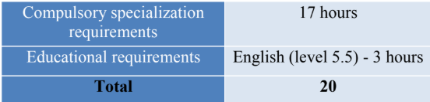

Overall Study Plan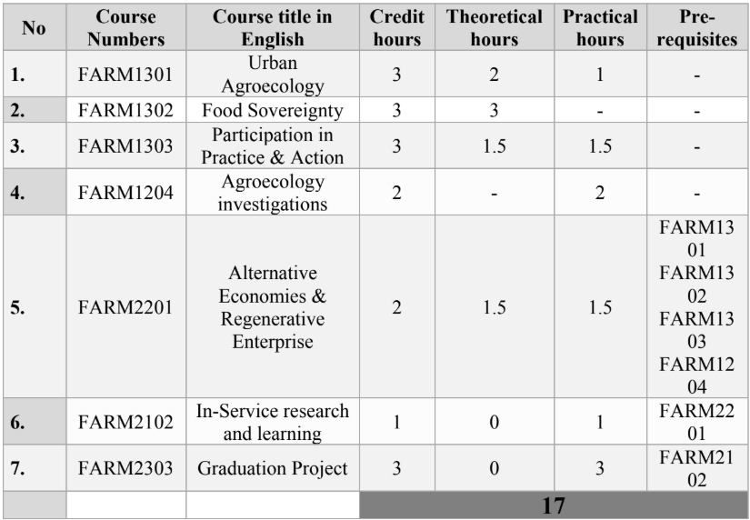

Distribution by Semester
Semester 1
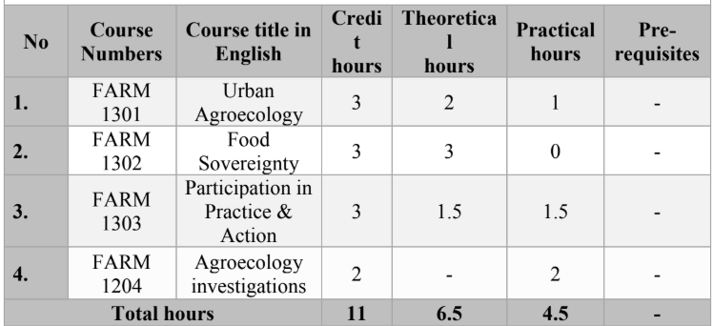

Semester 2
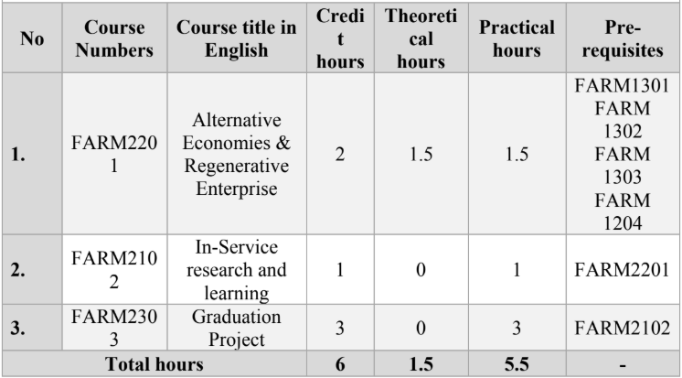

3.3 Assessment
The foundation mini-module will adopt a “formative assessment” approach (not marked), asking the students to write a short blog/commentary after each of the 5 lectures, discussing the contentious topics illustrated and how they informed (or not) the political positioning of the student in these domains.
The 4 thematic modules will each have one or two assignments (see course work -CW- at the end of each of the following chapters/module description. These assignments will cover a range of skills, including writing, oral presentation and debate.
In the next chapters we will discuss each of the modules in more detail, including content and syllabus of lectures, overview of teaching staff, assessment tasks (assignments) and criteria for evaluation, and learning outcomes.
4. MODULES & SYLLABI x 5

4.1 FOUNDATION MINI-MODULE (1 week)

Content and syllabus
This one week foundation module is an intensive introduction that acknowledges that students will be arriving from different professions and study backgrounds. This introduction therefore consists of 5 sessions that provide the intellectual and conceptual scaffolding that underpins the course and each module.
Lecturers/ teaching team:

# | Title and content
1 | Induction & Pedagogical approach: this session will illustrate the pedagogical approach underpinning the whole diploma, including how the topics and lecturers were chosen, assessment methods, collaboration with local and international organisations, policy makers and activists, and the requirements for active engagement and action learning required from the participants/students.
2 | Agroecological foundations - impacts & typologies of agroecology practice: this session will introduce contentions between intensive agriculture/, agribusiness and alternative forms of agriculture (organic, biodynamic, regenerative, permaculture, agroecology & baladi practices), and how they compare in their approach to climate change, soil health, biodiversity and nature stewardship, people’s health and social justice. Focus on 10 principles & 13 elements of Agroecology - as well as ‘stages’ (FAO)
3 | Food sovereignty foundations: this session will introduce key concepts such as political economy and political ecology, industrial capital and settler colonial histories, resourcefulness and epistemic rift, policies and change. It will pay particular attention to the theories of change that underpin these debates, and the role that these critical debates may have in shaping pathways of change.
4 | Knowledge foundations: This session will offer an overview on the politics of knowledge and constructions of power, politics of technology and history of farmer innovation, emphasising the role of PAR and PLA. It will particularly focus on discussing the contentious issues around technological innovation and power.
5 | Alternative economy foundations: This session will offer an overview on the alternative economic approaches offered in the module 4, and their underpinning value systems. History of the commons and its deconstruction, multifunctional farming, circularity and equitable resilience, feminist political ecology (FPE) and care, justice and solidarity economies.

Learning outcomes & Formative assessment: At the end of the lecture, students will be divided in small groups to discuss the ideas and approaches illustrated. After discussion, each student will write a short blog, to explain how the concepts were relevant to their experience, how they relate to these ideas, and whether these helped /informed their political positioning.

Useful all-round reading:

Kothari, A., Salleh, A., Escobar, A., Demaria, F., & Acosta, A. (2019) Pluriverse: A Post-Development Dictionary (e-book)

Pre-course engagement:

Watch: Untold Revolution: Food Sovereignty in Palestine الثورة غير المحكية- السيادة الغذائية في فلسطين

Read: FAO (2018) 10 Elements of Agroecology / العناصر العش رة للزراعة الإيكولوجية

توجيه المرحلة الانتقالية نحو استدامة النظم الغذائية والزراعية

Rooted (2025) Weaving resilience and resistance for systemic transformation. September 5, 2025 | Rooted editorial board and Nyéléni Global Forum | Issue 3 Weaving Resilience and Resistance.

HLPE (2025) Building Resilient Food Systems / الصمود بناء نظم غذائية قادرة على. Report 20. High Level Panel of Experts. Committee on World Food Security. Rome.

Graphics: FIAN. Corporate Capture of our Food System

Essential Course Reading

Salāmah. (2021). On the Meaning of Land: Restoring the Palestinian Selfفي معنى الارض: استعادة الذات الفلسطينية. المركز العربي للأبحاث ودراسة السياسات.

Global Alliance for the Future of Food. (2025) The Politics of Knowledge: Understanding the Evidence for Agroecology, Regenerative Approaches, and Indigenous Foodways

Carlile, R. and Cusworth G. (2021) Exploring the ebbs of flows of different agricultural movements. What distinguishes regenerative agriculture, organic and agroecology. TABLE Visuals. TABLE, University of Oxford, Swedish University of Agricultural Sciences and Wageningen University & Research.

Pimbert, M. (2015) Agroecology as an Alternative Vision to Conventional Development and Climate-smart Agriculture. Development 58, 286–298.
Pimbert, M., & Anderson, C. (2018). The battle for the future of farming: what you need to know. The Conversation.
Wezel, A., Herren, B.G., Kerr, R.B., Barrios, E., Gonçalves, A.L.R. and Sinclair, F., 2020. Agroecological principles and elements and their implications for transitioning to sustainable food systems. A review. Agronomy for Sustainable Development, 40(6), p.40.

4.2 AGROECOLOGY IN PRACTICE (Module 1)
Content and syllabus
This module (online & in-person) includes classes on soil and water management, nutrient cycling, integrated livestock and crop production, integrated pest management, investigations into agrobiodiversity and agroecological rehabilitation of farming landscapes, and critical approaches to technology adoption. This module involves field visits with farmers.
Class no. | Class Name
1 | Practices under the Agroecology umbrella applied to urban contexts for multifunctional farming systems: i.e., alignments between Baladi farming systems, permaculture, organic farming, agroforestry, silvopastural systems. Closed loop poly-cultural farming &/or territorial integration for resource connections.
2 | Soil 1: Soil biology vs Soil Chemistry - Soil Food Web. Nutrients cycles. Composting. Organic matter decomposition. Calculation of reserve nitrogen in soil. Mineralization and immobilization of N in soil.
3 | Soil 2: Soil-plant interactions. Sustainable soil management practices in urban settings. UA inter- and poly-cropping system.
4 | Field visit & Practical: Visit to composting unit / compost practical.
5 | Urban Water 1: Introduction to the water cycle. Water Usage & pollution challenges (aquifer vs groundwater). Examples of initiatives to recharge groundwater (i.e. nature-based solutions) - critical discussion.
6 | Water 2: Water management for sustainable UA. Alternative irrigation water resources (recovery water). Rainwater harvesting and efficient irrigation methods.
7 | Integrated Pest Management - push-pull, companion planting, wildlife,
8 | Practical: Seed - selection, saving, multiplication.
9 | Field visits 2: to urban and peri-urban farms - Integrating animals into the urban environment. Husbandry, welfare and feeding of the Urban Animals (Baladi Chickens, Rabbits, Pigeon, Ducks, Turkey, Sheep and Goat). Evaluating dis/benefits between indigenous and exogenous breeds.
10 | Agroecological restoration - intro to bioremediation of war-contaminated and denuded lands. (bioremediation specialist Leila Darwish + guest speakers)
11 | Practical: Vegetative propagation - seeds, cuttings, layering, grafting.
12 | Urban Animals 2: Urban animals’ and health care - including ethno-veterinary knowledge and practices. Practices in Livestock: Animal Production, Healthcare, and Livelihood Development.
13 | Urban agriculture in the context of climate change - tools and strategies for adaptation. Student discussion on agroecological practice typologies and baladi systems.
14 | Student presentations & Evaluation

Learning Outcomes
On successful completion of the module participants will be able to:
- Improved comprehension of natural resource interactions and fundamental principles of ecology and its application to agricultural systems in urban landscapes.
- Critically evaluate agricultural systems from an ecological perspective, by comparing and contrasting conventional and agroecological systems.
- Be able to apply the fundamental principles of ecology to multi-functional farming systems.
- Be able to assess and identify adaptation strategies with the potential to optimise resource use and knowledge.
- Critically discuss the benefits and drawbacks of different resource and land management systems.

4.3 URBAN AGROECOLOGY FOR FOOD SOVEREIGNTY (module 2)
Content and syllabus
This online module introduces key concepts and dominant discourses central to the industrial food system paradigm, colonisation and marketization. It also explores challenges and transitions to food sovereignty, community self-organisation, gender and feminisms, and power and participation in urban planning and food policy.
Module Lead: ?? (co-development lead Dr Chiara Tornaghi)
Teaching Team: is made up of Arab-speaking guest lecturers, based either in the Palestinian territories or internationally with either an academic expertise or a personal experience of the topics.

Class No. | Class Name
1 | More than urban agriculture - What is urban agroecology for food sovereignty? introduction to key concepts and dominant discourses (food security vs food sovereignty, organic agriculture versus regenerative/rewilding/permaculture/ climate-smart agriculture). Unveiling green washing, What do these practices have in common, and how do they differ? What is distinctive of agroecology (and of urban agroecology) and why is this important?
2 | Palestinian history through a political ecology lens: the power of dominant discourses and economic models, and how the current policy system can contribute to disempowering. The loss of the commons in Palestine and history of dispossession, and the destruction of indigenous knowledge systems. Political economy & ecology of the industrial food paradigm, colonisation, marketization green imperialism and green colonialism.
3 | Policies: Challenges to transitions towards urban agroecology & food sovereignty. How local policy contributes to eroding the Baladi food system (including the role of exporting water-rich crops, the embracing of the politics of aid, etc.)
4 | Agroecological Transitions: Building the agroecological and food sov transition. Community self-organisation – exploring concepts ie. resilience, resourcefulness, resistance as translated into practice.
5 | Gender, feminism & intersectionality – marginality, precarity and rights.  (including a reference of the NGO-isation and ‘projectisation’ of livelihoods - of women/gender projects). Part 1 - Gender, feminism & intersectionality in the Palestine context / Part 2 - Gender and feminism in Agroecology.
6 | Biodiversity & Health: Intersecting floral-biodervisity and agro-biodiversity: medicinal agroecology movements for health sovereignty. Intersecting ecological stewardship, food, nutrition and health. (+ Intro to CW1 assignment).
7 | Land and water: (Muna Dajani, LSE)
8 | Re-valuing the Commons: seed systems, land, knowledge - co-operatives, growing (CSAs), community kitchens.
9 | Cycling wastes – from public hazard to collective resource - practical and theoretical approach to ‘waste’ - western perspectives to organised waste management / and taking responsibility for one's own waste (village approach). Projectization of / imposition of western approaches. Potential to show what’s happening in Rosario, Argentina.
10 | Power and policy 1 -public participation in policy-making (social movements & right to food). Social movements and international gov arena (i.e. UN FAO processes). Intersecting agroecology, food sovereignty and the right to food. What opportunities do these platforms, agreements, and voluntary guidance offer to build the Gaza movement and to mobilise rights-based approaches? La Via Campesina near east facilitator/rep - UAWC. Hala Barakat (CSIPM).
11 | Power & policy 2 – What type of public policies for urban agroecology and food sovereignty do we need in Palestine? Local-level policy contextualisation from a municipality in Gaza/WB. A participatory / discussion session with students.
12 | Building the movement - from oppression to mobilisation: Translocal movements learning/conversations. Learning from and connecting with other agroecology movements in their own contexts (i.e. Latin America, other diaspora communities, indigenous people, etc.) and how they deal with the theft of land and resources. Strengthening international solidarity and cross-fertilisation (ie. 2 guest speakers highlighting examples from movements across the Global Majority).
13 | Student presentations - students design and present a campaign (group assignment CW1). A session with invited local authorities from the municipality? (facilitated by diploma lead)
14 | Self-evaluation and future action (students and teachers together), a CSA?

Assignments:
CW1: Group work to co-design a campaign that reimagines ie. food sov / waste integration / resource connections / UN right to food in Gaza (20 mins)
CW2: 1 individual written piece (ie. essay or case study) (2000 words)

Learning outcomes:
On successful completion of the module participants will be able to:

- To understand concepts and practices of food sovereignty in contrast to depoliticised concepts of food security, which are common in western and capitalist development work and discourse.
- To understand the complementarity of agroecology and food sovereignty to align ideals and practices of food production that are truly resource-conserving and inspired by more-than-human care.
- To understand the specific ways in which urban contexts and urban dynamics (i.e. urbanisation, land loss, soil pollution, etc.) require specific ‘urban’ agroecological strategies that counteract these dynamics (including, but not limited to, changes in land use planning, urban waste management, political organising and agroecological pedagogies, urban soil fertility management, etc.).
- To deepen the understanding of the interconnection between individual/collective power (through social movement organising) and policy change, in the different fields of land, soil, water, nutrition, etc.
- To identify the building blocks (community resources) that can enable food sovereignty and agroecology in Gaza (i.e. seeds banks, community kitchens, farm incubators, community supported agriculture, circular soil nutrients consortia, etc.)

Reading list: Add 5 indicative texts:
Rooted (2024) Building policies for agroecology to support healthy and just food systems. Rooted Magazine. September 2, 2024 | Rooted editorial board | Issue 1 Policies for Agroecology

4.4 PARTICIPATION IN LEARNING, PRACTICE & ACTION (module 3)
Content and syllabus
This module (online & in-person?) introduces participation and transdisciplinarity through which to better understand the politics of knowledge and its constructions. It challenges the ways we learn, and whose knowledge is important. By enacting a ‘scholarship of the people’ that centres fun, food and friendships – the module will explore how ‘formal’ education emerges from and reproduces the racist colonial project, and seeks to eradicate peoples’ diverse and culturally embedded knowledges borne of experience. In addition to the 7 sessions of class-based learning (21 hours), students will dedicate 21 hours of fieldwork to their agroecological investigations working in groups to set up, monitor and document their food growing experiments (ie. integrated pest management, companion systems, soil moisture protection, natural fertility). To be continued over summer months between semesters - July to August.
Kadoorie / UCAS lecturer: ?? (co-development lead Dr Georgina McAllister) - it will be difficult to find someone to lead this module given its decolonising bottom-up student-led nature) - this module was initially envisaged as being taught outside of the classroom - in nature - at the beach / under trees. So we need to really think this one through. Similarly WB students have movement constrictions. At a push this module could be taught online (as was done during COVID) but would be sub-optimal. If online, then session #5 would ideally be facilitated outside (in WB and Gaza)

Class No. | Class Name
1 | River of Life – how did you get here (students pre-prepare to present their visual ‘river’ in session 1) – getting to know each other through personal journeys.
2 | Photo-voice 1 – exploring forms of oppression around you - students capture an image that encapsulates this, and shares what it means to them in the class.
3 | People’s circle 1 – shared reading (ie. chapter 2 from Freire’s Pedagogy of the Oppressed, students are invited to reflect and learn together through collection exploration of each others’ interpretations of the piece and how it made them feel, involving reflections on students own experiences of education to date.
4 | Photo-voice 2 - exploring forms of oppression within - students capture a shot that encapsulates this, and shares what it means to them in the class.
5 | People’s circle 2 – bring, share and discuss food – through memories, stories and song! (all students are asked to bring food made from their grandmother’s recipe, using baladi ingredients, presented on their grandmothers plate)
6 | People’s Circle 3 - shared reading (ie. Ngugi wa Thiong’o (1981) Decolonising the Mind (Introduction p1-3) OR Bilal Salemeh (2021) On the Meaning of Land: Reclaiming the Palestinian Selfhood (Arabic text). Students are invited to reflect and learn together through collective exploration of each others’ interpretations of the piece, particularly the concept of the ‘intellectual peasant’ and how it made them feel.
7 | Image theatre – in groups of 5 are given one theme to co-develop and enact – ie. what does agroecology mean to you; what does Arab/Palestinian feminism mean to you; what does decolonial knowledge mean to you; what does food sovereignty mean to you. Wrap-up reflection and discussion.
8 | 3 hours - agroecological investigation working group & field experiment
9 | 3 hours - agroecological investigation working group & field experiment
10 | 3 hours - agroecological investigation working group & field experiment
11 | 3 hours - agroecological investigation working group & field experiment
12 | 3 hours - agroecological investigation working group & field experiment
13 | 3 hours - agroecological investigation working group & field experiment
14 | 3 hours - agroecological investigation working group & field experiment

Assignments
CW1: Document and write up agroecological investigation in teams - presented report.
CW2: Essay on participatory learning & practice.

Learning Outcomes
On successful completion of the module participants will be able to:
- Display a critical understanding of conceptual, theoretical and methodological dimensions of participatory action research, including ways in which knowledge is situated, gendered, racialized, and colonial and thus has contributed to social injustice, oppression and domination.
- Demonstrate an awareness of ways in which participatory action research is theorized and enacted, such as through popular education, as well as indigenous, environmental, and decolonial approaches.
- Demonstrate a critical awareness of, and practice using, creative participatory action research methods.
- Deepen understanding and mutual respect, through collective practice and action, of food as a site of popular struggle for epistemic justice.

Reading list:
Salāmah. (2021). On the Meaning of Land: Restoring the Palestinian Selfفي معنى الارض: استعادة الذات الفلسطينية. المركز العربي للأبحاث ودراسة السياسات.
Wa Thiong'o, N. (1998). Decolonising the mind. Diogenes, 46(184), 101-104.
Anderson, C., Buchanan, C., Wakeford, T., Chang, M., & Rodriguez, J. S. (2017). Everyday experts: How people’s knowledge can transform the food system. Coventry University.
Freire, P. (1970) Pedagogy of the Oppressed. / or Freire, P. (1992) Pedagogy of Hope. Routledge.
McGregor, D. (2004). 'Traditional Knowledge and Sustainable Development: Towards Coexistence’, in In the Way of Development. Indigenous Peoples, Life Projects and Globalization, London: Zed.
Pimbert, M.P. (2017). Food Sovereignty, Agroecology and Biocultural Diversity. Constructing and contesting knowledge. Oxon: Routledge.
Rosset P., Valentín Val, Lia Pinheiro Barbosa & Nils McCune (2019) Agroecology and La Via Campesina II. Peasant agroecology schools and the formation of a sociohistorical and political subject. Agroecology and Sustainable Food Systems, 43:7-8, 895-914, DOI: 10.1080/21683565.2019.1617222
De Sousa Santos, B. (2015) Epistemologies of the south: Justice against epistemicide. Abingdon: Routledge
Pimbert, M. P., Barry, B., Berson, A. & Tran-Thanh, K. (2010) Democratising agricultural research for food sovereignty in West Africa. London: IIED.
Haraway, D. (1988) 'Situated Knowledges: The Science Question in Feminism and the Privilege of Partial Perspective'. Feminist Studies 14 (3), 575-599
Grosfoguel, R. (2007) 'The Epistemic Decolonial Turn'. Cultural Studies 21 (2-3), 211-223
Schooling the World. (824) schooling The World مترجم - YouTube

4.5 ALTERNATIVE ECONOMIES & REGENERATIVE ENTERPRISE (module 4)
Content and syllabus
This module explores organisational strengthening, asking: how do we learn across intersections to build solidarities; how do we nurture our foodways to reconnect culture, food and nature through resourcefulness, resilience and resistance? Students will critically engage with how language is constructed, and hear from a range of community networks and activists about the different organising models and adaptations they are working with. In addition to 30 hours of class-based learning, Students will also be required to contribute a minimum of 12 hours of in-service research and learning in their existing place of work or a research placement.
Module Lead: Lina Isma’il (development co-leads Samah Hamouda & Dr Georgina McAllster)
Teaching Team: To be developed by Lina Isma’il, with guest lecturers/speakers drawn from farmer and movement networks. Ie. Community self-organisation - Yara Dowani, Mohammad Khwerah, Samer Karajah.
Class No. | Class Name
1 | (the why) Emergence of the capitalist economic model - underpinnings, dominance & market logics (extractive & export-focussed with ‘supply chains’). What is productivism, what does it measure, what does it not measure, and why it matters.
2 | Introducing the history of the Palestinian commons, multi-functional production & territorial markets. Positioning pre-existing and ‘alternative’ economies (food webs) in our everyday actions and activism. What is ‘scaling’ (up, out or deep), and which scales are effective?
3 | Seed & knowledge networks (ie. Al Qarara - Gaza, Heritage Seed Library, UAWC - WB, Seed networks in Lebanon - Buju). Background to seed laws (UPOV91) and ‘new improved’ varieties. Heritage baladi seed & farmer adaptation and innovation.
4 | Farming coops, incl youth led; CSAs & other formations for social organisation
5 | Territorial markets (Palestine - PAF; Rosario - Argentina). public procurement, solidarity marketing
6 | Farmers reclaiming space ie. Al Barakat Wheat - reclaiming urban land for traditional grains in Aman (Lama Khateeb); women-led rooftop food production in Egypt (Hala Barakat)
7 | Public policies that enable or obstruct agroecological transitions ( incl ‘hygiene standards’ etc)
8 | Applying participatory measurements and tools to evaluate the integration of ecological, social, cultural, economic and political dimensions needed to transform food systems.
9 | Enterprise design, market, research, scaling out/connecting up, and marketing - a transdisciplinary approach and why it matters from a place-based just food systems perspective.
10 | Solidarity networks & movement building across borders - the politics of knowledge and epistemic justice.
11 | 3 hours - In-service research and learning placement (or place of work)
12 | 3 hours - In-service research and learning placement (or place of work)
13 | 3 hours - In-service research and learning placement (or place of work)
14 | 3 hours - In-service research and learning placement (or place of work)

Assignments: Students will produce one assignment as part of their graded coursework:
CW1: technical report associated with their in-service research & learning placement (FARM2102) that draws on key learning points from taught class within this module.

Learning Outcomes
On successful completion of the module participants will be able to:
- Understand histories of, and be able to differentiate between, economic models and their logics, and the implications for people and nature.
- Identify alternative models for pursuing food sovereignty that are socially just and within planetary boundaries.
- Demonstrate a critical awareness and imagination of alternative economic approaches based on social solidarity and organisation that connects urban and peri-urban enterprises towards agroecology for food sovereignty.
- Identify and co-develop participatory action research with real-world impacts.

Reading List (5 indicative texts):
Isma’il, L. (2025) Reclaiming land, restoring power: A grassroots path to a social and solidarity economy in Palestine. Rooted Magazine. September 5: Issue 3 Weaving Resilience and Resistance

4.6 FINAL PROJECT
For their final graduation project, students select an action research focus of their choice, potentially a case study from their Module 4 in-service research & learning placement within a farming, policy, or arts collective to build on their learning throughout the programme. This final project might take the form of a written thesis or creative multimedia output.

